**Green Group Requirements Document**

**Green Group:**

Austin Heward

Crystal Sciarrino

Dennis Witt

Jeremy Clay

* Inventory Software Requirements Document (SRD) for Netflix

1. **Introduction**

***This software requirements document includes background and reference information pertaining to the development and use of ClientWatch (CW)***

* 1. **Purpose of this Document**

The purpose of this Software Requirements Document (SRD) is to provide the requirements for use of ClientWatch (CW) for users and developers. Requirements listed for clients cover how the software can be utilized from the client’s perspective. These requirements contain information about the distinct roles that can use the software. Requirements listed for developers have been added to describe the software from a developer’s viewpoint. These requirements include information on the performance and functionality of the program.

* 1. **Questions for the Client**
* Will this software have to work alongside another software?
* What hardware will this software need to perform?
* What functions would you like the software to perform?
* What roles will be established in this software?
  1. **Answers from the Client**
* Yes, this program will have to interface with the Netflix client base currently in place.
* Ability to search clients based on a single piece of information such as address, phone number, email, etc.
* Administrators, Sales Reps, Account Reps. Admin will have access to sensitive information that Sales and Account reps would not where Sales has to ability to start a new client or terminate an old one and account reps manage and track billing
  1. **The needs of the Client**
* Ease of access- must be able to navigate the program without too much computer knowledge
* Basic search function.
* Basic input functions for creating and deleting accounts
* Visually simple to look at and identify functions
  1. **Scope of the Development Project**

The scope of ClientWatch (CW) includes the maintenance, regulation and safekeeping of client information. All billing and personal information will be secure within the database allowing company clients to feel safe and comfortable with giving out billing info. Also, the scope will track and ensure accuracy of active services by tracking that monthly payments are on time and the customer’s services are not interrupted while protecting the client from potential loss due to customers receiving free service. It will also provide the sales and accounts personnel ways to input new customers, terminate current ones, stop services for past due customers and create services for new subscribers.

* 1. **Definitions, Acronyms, & Abbreviations**

|  |  |
| --- | --- |
| Term | Defintion, Acronym, or Abbreviation |
| C# | Programming language that will be used to build the Clientwatch software. This language was made by Microsoft |
| SRD | Software Requirements Document |
| CW | Abbreviation for ClientWatch aka the name of this software |
| .NET | .NET Framework is a programming model made by Microsoft used by developers for rapid development that includes helpful software technologies |
| PC | Personal Computer running the Windows Operating System |
| Mobile Device | Any mobile technology such as a phone (Iphone, Android) or tablet (Ipad, Android Tablet) |
| Media Player | Any home device connected to a Television display: Roku, Apple TV, Amazon Fire Stick, Playstation, Xbox, Smart Blu Ray Player |

* 1. **References**

*No specific references at this point.*

* 1. **Overview of Document**

This document includes the following information:

Section One contains:

* Program overview

Section Two contains:

* Requirements involving client use of this software.

Section Three contains:

* Requirements involving developer use of this software.

1. **Client-Oriented Requirements**

***The purpose of this section is to define the requirements of this software in a way that a client can understand.***

* 1. **User Personas**
* Administrator- Personnel with full access to all portions of the program.
* Account Reps- Can access all billing information, time subscribed, can put accounts on hold, bring accounts out of holds, track payments, create new accounts.
* Subscriber- Paying customer of Netflix
  1. **Use Cases**

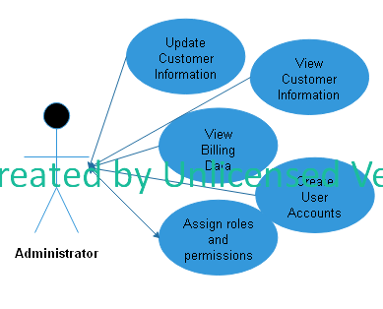

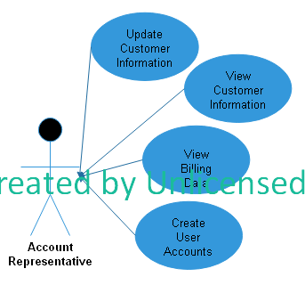

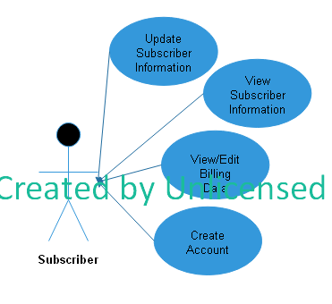

*This section showcases Use Cases of the software and provides detailed diagrams for the roles of the User Personas created in 2.1. Use Cases are basically just diagrams of the roles and their responsibilities as shown in the group assignment document.*

* 1. **Product Interfaces**
* Hardware Requirements: This software requires a Windows PC with x86 or x64 bit mode support, 1.6 gigahertz (GHz) or higher processor and 512MB Ram
* While the Netflix application can run on various specialized Media Players, this software (CW) can only be ran on a PC
  1. **Functional Requirements**

This software enables Netflix service administrators to perform modifications to client accounts. Through this software, it is possible to look up, create, cancel or halt client accounts.

* 1. **Non-Functional Requirements**

This product will require an updated and functioning security program to ensure no spyware or other types of malware effect the security and integrity of the program.

* + - 1. **Interface: User:**

**To be determined**

* + 1. **Physical Environment:**

**To be determined**

**2.6.3.1 Performance: Response Time**

**To be determined**

**2.6.3.2 Performance: Resource Utilization**

**To be determined**

**2.6.4 Quality**

**2.6.5 Security**

**It is highly recommended that the user invest in security software however there are systems in place for security such as exclusive access to certain databases based on your account and user type.**

**2.6.6 Organizational Issues**

**To be determined**

**2.6.7 Standards Compliance**

1. **Developer-Oriented Requirements**

***Currently in development so there is no specific information to provide. The product will be developed in Visual Studio version 2017.***

* 1. **Functional Requirements** 
     1. **Template of Functional Requirements**

|  |  |
| --- | --- |
| Purpose | A description of the functions and reason for this software |
| Inputs | Information that is input into the system by users to access or modify data |
| Processing | The steps taken by the data that was input within the software |
| Outputs | The resulting data that the software displays |

* + 1. **Software Specific Functional Requirements**

|  |  |
| --- | --- |
| Purpose | The software will allow select users to look up client information based on their name for the Netflix video streaming service and modify that information as needed |
| Inputs | The clients name and password to the Netflix service will need to be entered to access the account information   * The password should not be more than 15 characters and can include special characters and numbers |
| Processing | The name of the client that was input will be searched for within the database and if found it will return an output  If not found a new account can be added to the database |
| Outputs | If the name is found in the database the clients account information will appear along with a command to modify the information |

* 1. **Data Requirements**

*See section 2.5.*

* 1. **User Requirements**

Approval from system administrator

* 1. **Hardware Requirements**

This software requires a Windows PC with x86 or x64 bit mode support, 1.6 gigahertz (GHz) or higher processor and 512MB Ram

* 1. **Software Requirements**

To be determined

* 1. **Performance Requirements**

To be determined

1. **Storyboard**

ADMINISTRATOR: VIEW BILLING DATA

